
Player’s Quick Start Guide
Last Updated
January 3, 2025

Table of Contents

- Scheduling & Accessing Workspaces Using the XP Cyber Range or NICE Challenge Webportal
- Starting a Challenge
- Performing a Challenge
- Submitting a Challenge
- Viewing Challenge Submissions
- Challenge Tips & Top FAQs
- Console Support & Availability

Scheduling & Accessing Workspaces Using the XP Cyber Range or NICE Challenge Webportal

Workspaces Overview
Players must be added to an assignment by a curator before they can gain access to a workspace and begin attempting challenges. The curator determines what challenges may be attempted, as well as how long players will have access to a workspace. Below are screenshots showing how to identify if a player has available workspaces or any workspaces pending scheduling.

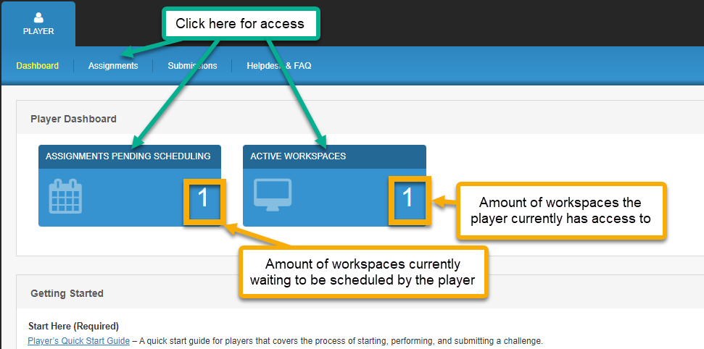

Accessing an Active Workspace
Workspaces become available to players at approximately 3:00 AM (Pacific Time) on their designated start date. Once a workspace is available, players will see a button labeled "Open Workspace", which they can click on to continue with challenge selection and deployment. Workspaces expire at 11:59 PM (Pacific Time) on their designated end date, at which point any challenge attempts in progress will be submitted automatically.
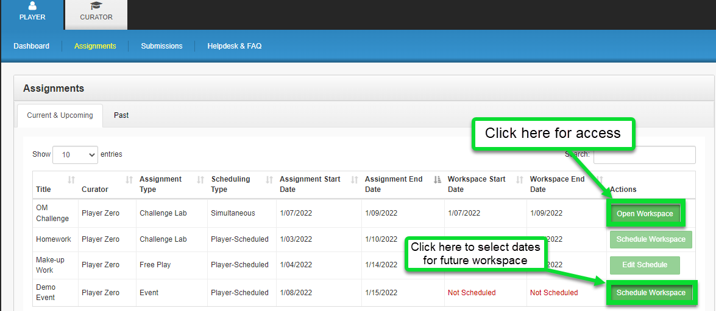

Scheduling a Workspace
Players must be added to a Player-Scheduled Assignment before they may schedule a workspace for themselves. If a player has an assignment that is pending workspace scheduling, the words "Not Scheduled" will appear in red under the assignments "Workspace Start Date" and "Workspace End Date" columns. Selecting the "Schedule Workspace" button will navigate them to the Workspace Scheduling page.

During assignment creation, curators specify a date range for players to schedule workspaces for themselves. This is the Assignment Phase. On the Workspace Scheduling page, players are prompted to select a date range within the Assignment Phase during which they would like to gain access to a workspace.

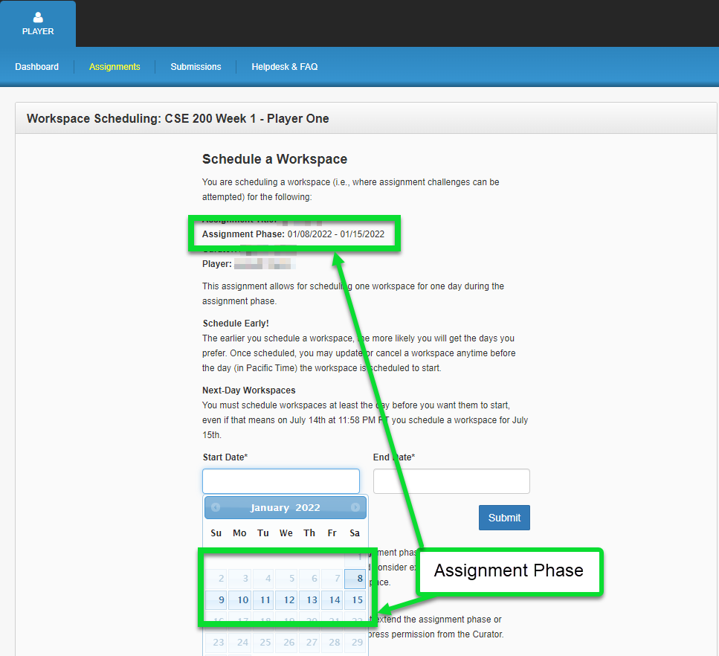

Starting a Challenge Using the XP Cyber Range or NICE Challenge Webportal

Selecting a Challenge
Once inside an active workspace, players are presented with a sortable list of available challenges with two available action buttons. The “View” button displays expanded challenge information and the “Deploy” button will deploy that challenge onto the current workspace.

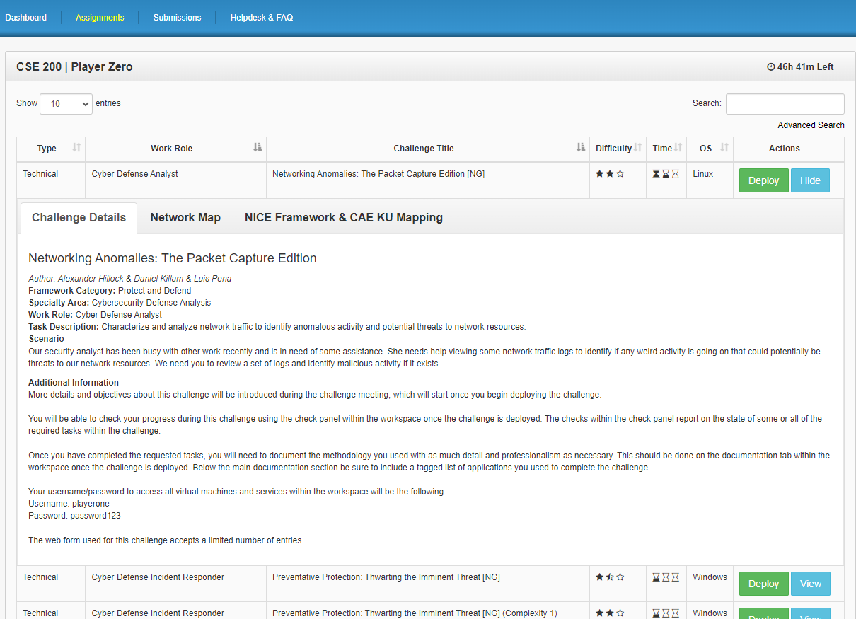

This list is organized by a variety of useful information including the following…
- Type - At this time there are 3 different types of challenges. Technical, which is a challenge where the player generally needs to alter (i.e. install/update software, fix issues, etc) the VMs within the environment in order to reach a desired end state. Hybrid, which is a challenge where the player observes and analyzes the state of the VMs within the environment and writes a report/policy as the primary deliverable. Threat Sandbox, where the player is educated about a threat and encouraged to experiment with it in the environment.
- Work Role - This field comes directly from the DoD Cyber Workforce Framework and NICE Framework and is what the challenge is mapped to/designed from in terms of content.
- Challenge Title - The challenge’s name.
- Difficulty - The relative difficulty of the challenge.
- Time - The relative time it should take to complete the challenge.
- OS (Operating System) - The main operating system used to complete the challenge. This does not, however, mean that the challenge is limited to that operating system completely.

Understanding Challenge Details
When reviewing challenges, the top-level (what is displayed in the list) information is only to help players find what they are looking for, in general. More important details can be found below this layer, they become visible once the “View” action is used. The various sections under the “Challenge Details” tab are listed and explained below…
- Framework Category/DCWF Element, Work Role, & Task Description - These fields come directly from the DoD Cyber Workforce and NICE Framework and are what the challenge is mapped to/designed from in terms of content.
- Scenario - A brief business scenario written to give a realistic take on how this challenge could manifest using real-world context.
- Additional Information - Extra information that will aid in the completion of a challenge. Often this section includes important details that are required to complete a challenge properly.

Understating Known Issues
The tab labeled “Known Issues” can be clicked to reveal information about known issues related to the selected challenge. This section will display a detailed description of the issue along with any known workarounds and the potential impact the issue may pose to the challenge submission report.

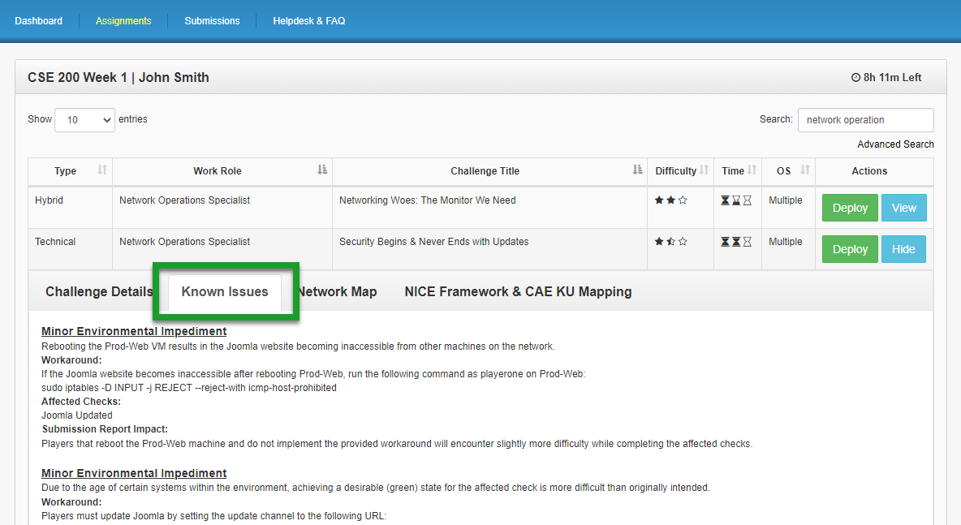

Challenge Deployment
Challenge deployment, on average, takes between 5-10 minutes once the deployment request leaves the queue. However, some challenges take longer to deploy than others. In the cases that the challenge will take longer than 10 minutes to deploy the average deployment time is listed in the “Additional Information” section of the “Challenge Details” tab.

After clicking “Deploy”, players will be presented with the Meeting Chat interface. During this phase, players will witness a meeting take place among fictitious colleagues which will provide valuable details regarding the tasks at hand.

Once the challenge has finished deploying, the progress bar at the bottom of the screen will be replaced by a button that reads “Begin Challenge”.

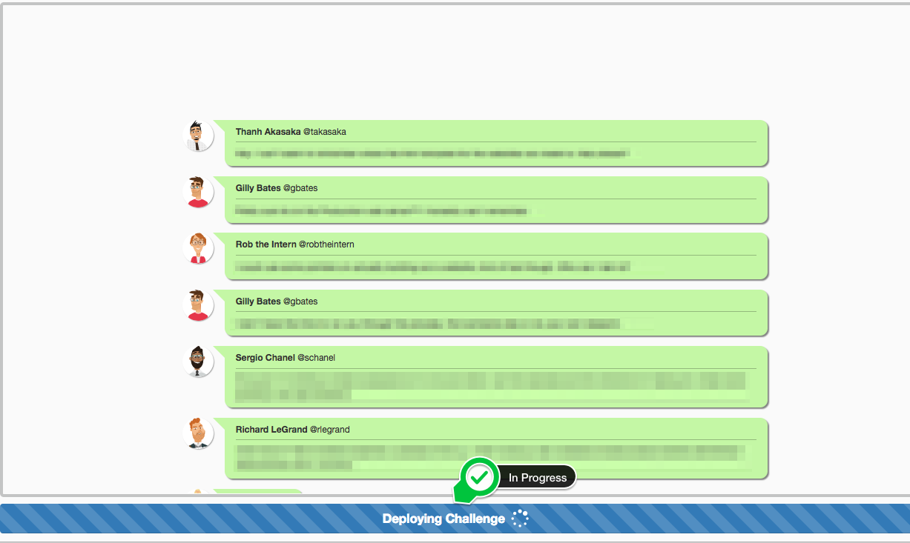
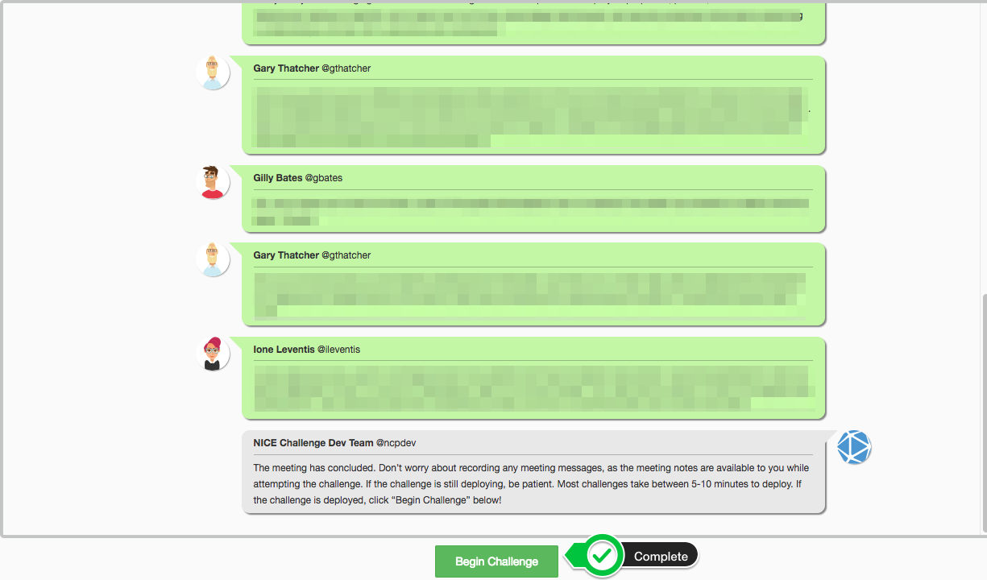

Known Issues Reminder
Players will be reminded of any known issues related to any particular challenge once the meeting has concluded. Details of the known issue, along with workarounds and potential impact on checks, will be listed in a gray chat bubble sent from the Dev Team.

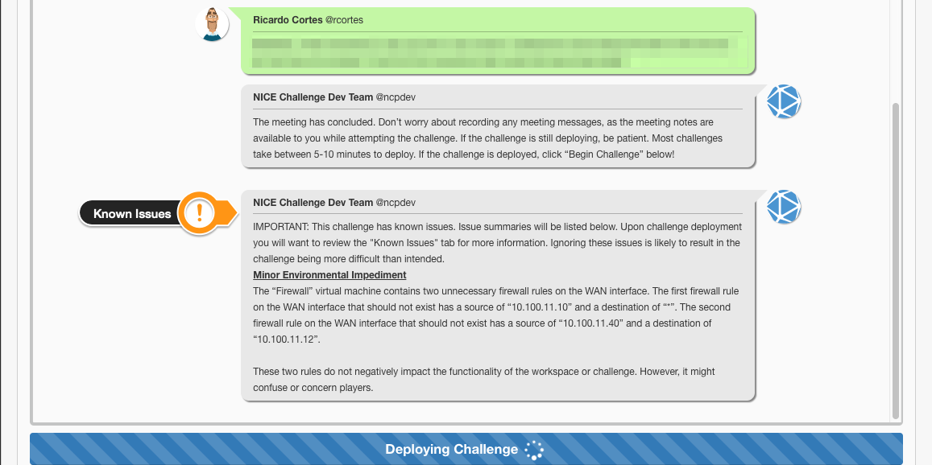

Returning to Challenge Selection After Deployment
If players wish to select/deploy a new challenge they will need to end the current challenge attempt. This can be done by selecting the “Documentation” tab within the active workspace, providing written documentation, and using the green button labeled “Submit Challenge Attempt” located on the top right of the screen.

Important Submission Note: If players start any challenge and need/want to end the challenge attempt, that challenge attempt will be recorded. All challenge attempts are recorded and sent to the curator for assessment as submissions.

Performing a Challenge Using the XP Cyber Range or NICE Challenge Webportal

Gathering Information from Meeting Chat
Once a challenge has started to deploy onto an active workspace the Meeting Chat animation will display VERY important information, often CRITICAL to the completion of the challenge. After the meeting animation has concluded, this information can be reviewed by selecting the “Meeting Notes” tab. Players should review all of these communications carefully at the beginning of each challenge.
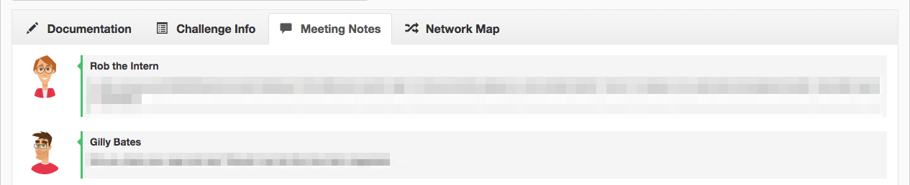

Understanding & Tracking Checks
After reviewing the challenge’s meeting chat, the second thing a player should review is the challenge’s checks. Technical challenges often have many checks, Hybrid challenges often have none, and Threat Sandboxes often have one that is used to indicate if the threat is still active or not. Fields in the check section have the following types of data in them…
- Status - This field will show either a red ✖ (denoting an incomplete objective), yellow ✖ (denoting an obstructed check), a green ✔ (denoting a complete objective), and a grey ? (denoting an unchecked objective).
- Check Description - This field displays text related to the check, usually a brief description of what the check is looking for.
- Status Info - This field will show extended status information relating to a check’s status.
- Last Changed - This field shows the last time the check status changed. This is not to be confused with when a check was last run. Checks generally run every 60 seconds unless otherwise stated in the check description.

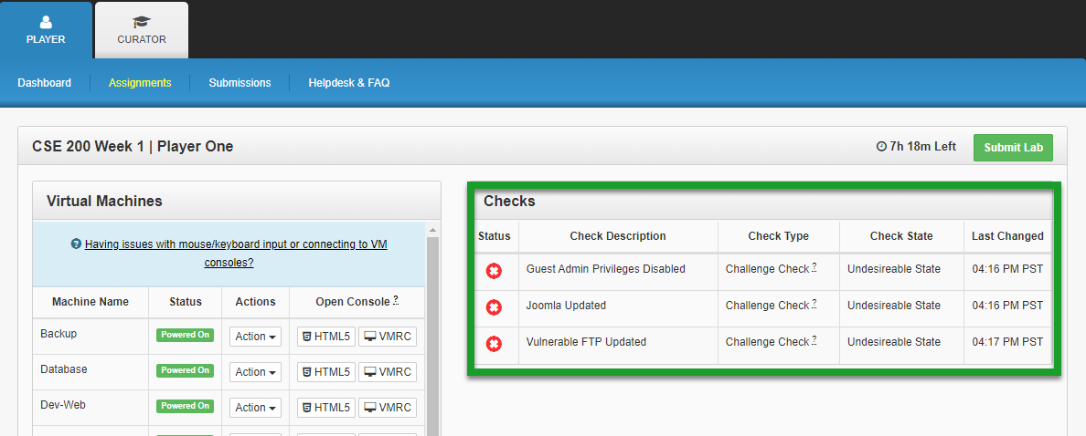

When doing a technical challenge, the main objective is reached when all the checks are reporting back a green ✔ in the status field.

Consoling into VMs & Login Details
Having reviewed the meeting chat for context and the checks that need to be satisfied, it is finally time to get into the VMs. Using the context and the network map, the player should be able to identify what VMs need to be interacted with. If working on a technical challenge, the player will likely need to make changes to these VMs within the workspace. When doing a hybrid challenge, however, they often need only observe specified information within.

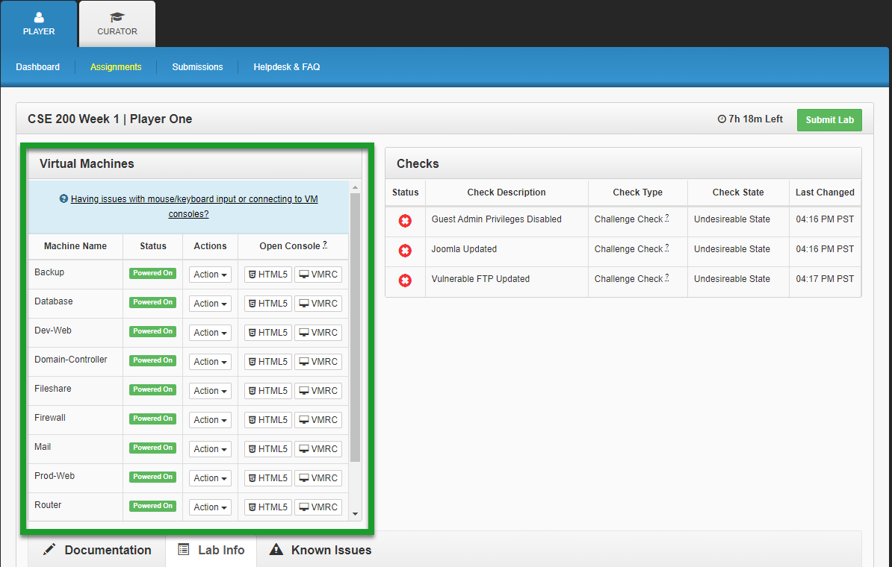

Machine/Service/Application Logins within the environment should always be the same unless the challenge, under the additional information field or meeting chat, states otherwise. The normal login credentials are the following…
- Username/Login: playerone
- Password: password123

Submitting a Challenge

Writing Documentation & Drafts
While completing the challenge, or at the end of the challenge, players need to document their challenge solution. The player should format their documentation as professionally as possible and document with as much detail as they feel is needed to clearly explain their solution.

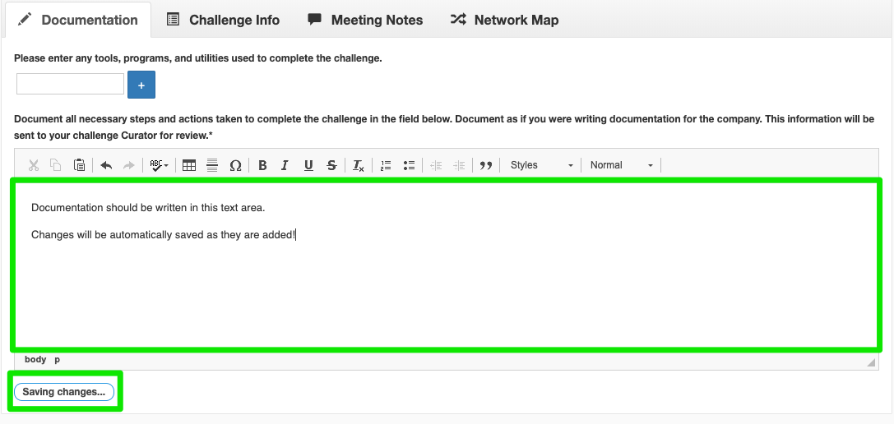
Player documentation is automatically saved whenever changes are made to the text area. This is so that if the player loses their internet connection or accidentally navigates away from their workspace they will not lose their documentation while the challenge is still in progress. A message will display below the text area whenever the process of saving documentation is occuring.

Adding Software/Utilities/Coding Languages to the Tools Used List
Along with documenting their solution to the challenge, players will want to tag software applications, operating system utilities, and coding languages utilized in their solution in the tools used list. However, coding languages should only be added when the player uses a coding language to write a script or program to aid in their completion of a challenge.
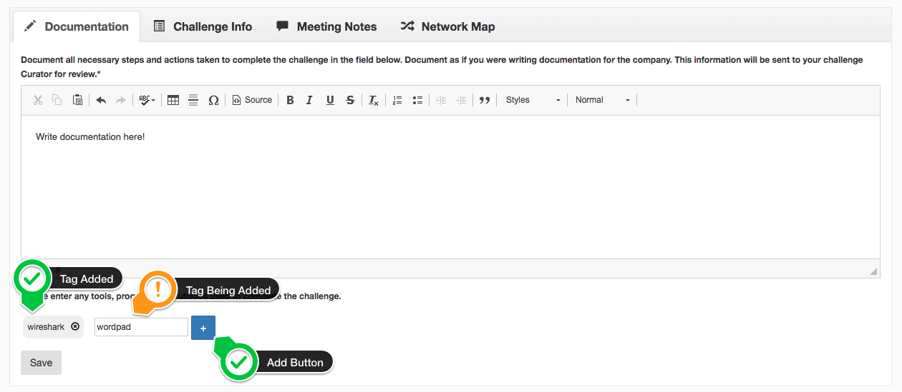

Final Submission & Ending the Challenge Attempt
Once the player is satisfied with their challenge attempt, has documented their solution, and has added their tools used, it is time to end the challenge attempt. This is done by clicking the “Submit Challenge Attempt” button located on the top right of the page. Do NOT hit this button until the attempt is COMPLETELY DONE. A player CANNOT take the submission back or edit it once it is submitted. This will end the challenge attempt and send the results to their curator.

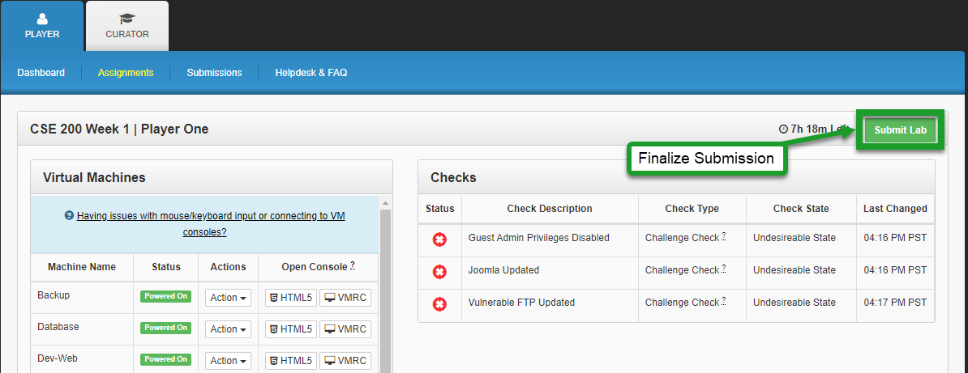

Viewing Challenge Submissions

Navigating to the Submissions Page
Upon successfully logging in to the XP Cyber Range or NICE Challenge Webportal, players may navigate to the Submissions page by clicking on the “Submissions” link in the navbar. By default, challenge submissions will be sorted by date of submission.

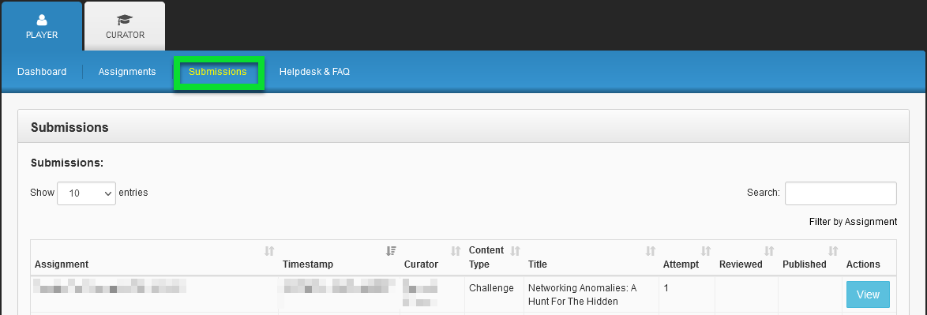

Reviewing Challenge Attempts
Challenge submissions are listed in the table located in the upper half of the page. The table can be sorted by clicking on the table header corresponding to the criteria by which you wish to sort (assignment, timestamp, etc.). Challenge submissions that have been reviewed by the curator will display a checkmark in the column labeled “Reviewed”.

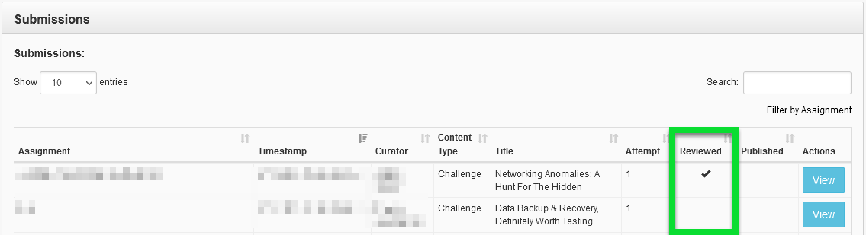

Viewing Challenge Attempt Details
Clicking the green button labeled “View” on any row will populate the Submission Review view, located below, with details corresponding to that particular challenge submission.

Understanding the Challenge Attempt View
The challenge attempt view includes submission details such as:
- Title
- Complexity
- Attempt Duration
- Check Status
- Tools Used
- Submitted Documentation
- Submission Feedback

Each challenge consists of a series of checks that players must satisfy in order to complete it. These checks, along with their descriptions, are listed in the section labeled “Final Check Details”.
An overall assessment of the player’s attempt to satisfy the challenge checks can be found under the section labeled “Full Check Pass”.
Players are asked to provide a list of any tools used during their challenge attempt. This list is displayed in the section labeled “Tools Used”.
Most challenges prompt the player to submit some sort of written documentation detailing how they arrived at a solution. This documentation will be displayed in the section labeled “Submitted Documentation”.
Once the curator has reviewed a challenge attempt, their finalized review is displayed in the area labeled “Submission Feedback” at the bottom of the page.
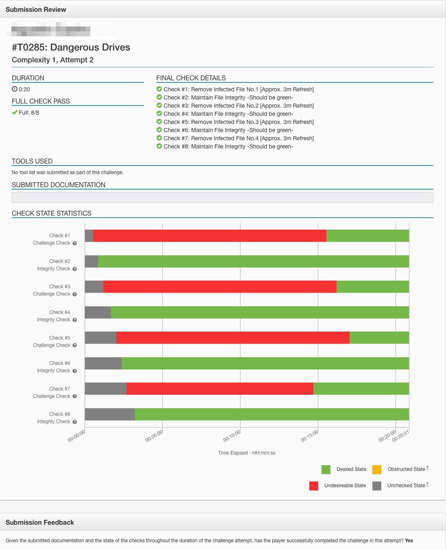

Exporting Submissions to PDF
Challenge submissions may be exported to PDF by clicking on the blue button labeled “Generate PDF” located on the top right of the Submission Review pane.
Generated PDFs include the DoD Cyber Workforce Framework and NICE Framework mappings associated with the challenge that was attempted. They may be printed out and presented to parties interested in the assessment of the skills of the player who performed the challenge.
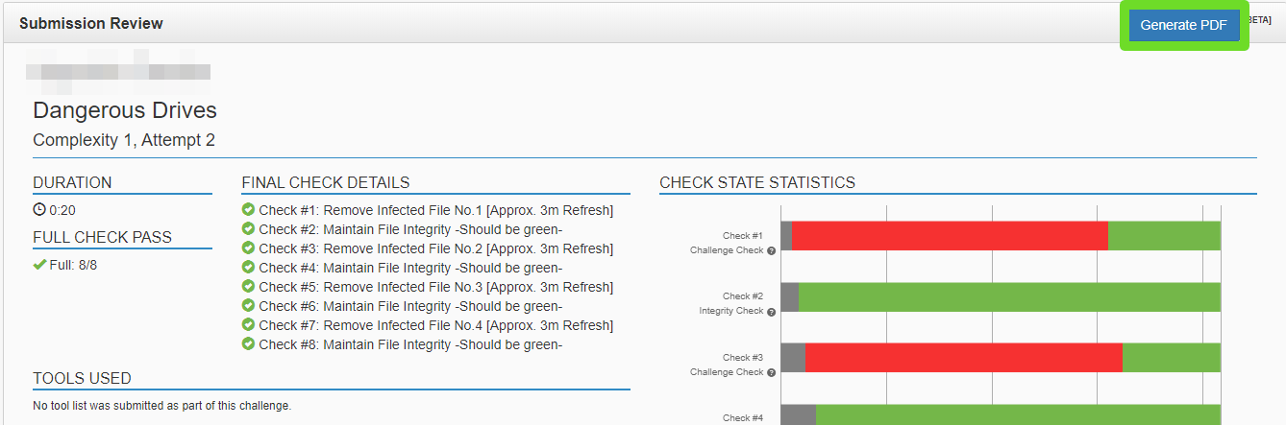

Verification - An interested party may verify the authenticity of the printed report by scanning the QR code or visiting the address provided near the top of the document. The address provided will render a nearly identical PDF with values redacted to conserve privacy. The interested party may review the presented values and ensure they match the physical report they have been provided with.

Curator Publishing - Curators have the option to “publish” their reviews of challenge submissions. Once a curator publishes a review, they will no longer be able to alter that review. Upon publishing a review, they also consent to their name and the name of their educational institution appearing in a box labeled “Reviewed By” near the top of the document. PDFs generated from challenge attempts that do not have a review published by a curator will have a statement in place that explains the report has not yet been published and validity is not supported.

Challenge Tips & Top FAQs

Challenge Tips

Don’t Forget About Additional Info!
When gathering information about what needs to be done for a challenge, make sure to also review the “Additional Information” section under the “Challenge” tab. The check descriptions and meeting chat draw the most attention, but missing something in additional info can really set a player back.

Checks Cycle Every Minute
This means that the second a player makes a change, it might not reflect in the check status for another 60 seconds. Make changes carefully and thoughtfully then be patient. Otherwise, a correct solution might slip through between checks.

Avoid Network & Permissions Changes
Unless the challenge is specifically asking the player to make changes to the network configuration, do not do this. Checks will often depend on these configurations remaining static. This tip is also true when it comes to permissions. Unless the challenge specifically instructs the player to, or it is obviously needed, do not alter permissions on files/services/users/servers to be more restrictive. Players are welcome to make note and suggest changes in their documentation, of course. However, again, it may restrict a check from functioning properly.

Top FAQ Articles

I am having issues solving a challenge, what should I do?

The HTML5 Console is Not Working Right! (Mouse/Keyboard Input Issues)

What is the username/password for X VM or X service in the workspace?

Can I copy and paste from my local machine to the virtual machines in the workspace?

Do I need to finish the challenge in one sitting or can I leave and come back to it later?

What time do assignments and workspaces begin and end?

Console Support & Availability
Review the XP Cyber Helpdesk article: Which operating systems/web browsers are supported?

Workspace - A live environment assigned to a user for the purpose of attempting challenges.
Assignment - A time window, defined by a Curator, in which a set of users may schedule workspaces or have workspaces scheduled for them for the purpose of performing challenges.
Player - A user which performs challenges; often a student.
Curator - A user which adds players, creates assignments, and reviews challenge attempts; often a professor.
Challenge - A defined scenario, based on a DoD Cyber Workforce Framework and NICE Framework Task from the perspective of a DoD Cyber Workforce Framework and NICE Framework Work Role. Often includes a business scenario, meeting chat, and checks. Each challenge is designed to work within a specific environment.
Environment - A defined set of VM images, configurations, and extended context. It is designed to create a realistic set of systems, networks, and users which support a fictitious organization with a defined purpose.
Check - A monitored state, condition, or event within a challenge usually correlated with a challenge objective.

